Dev c programming codes by typing the given (hello,world)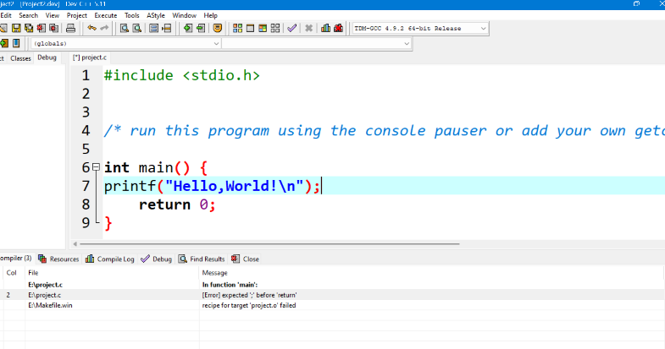

This is what dev c display after compile and running the code

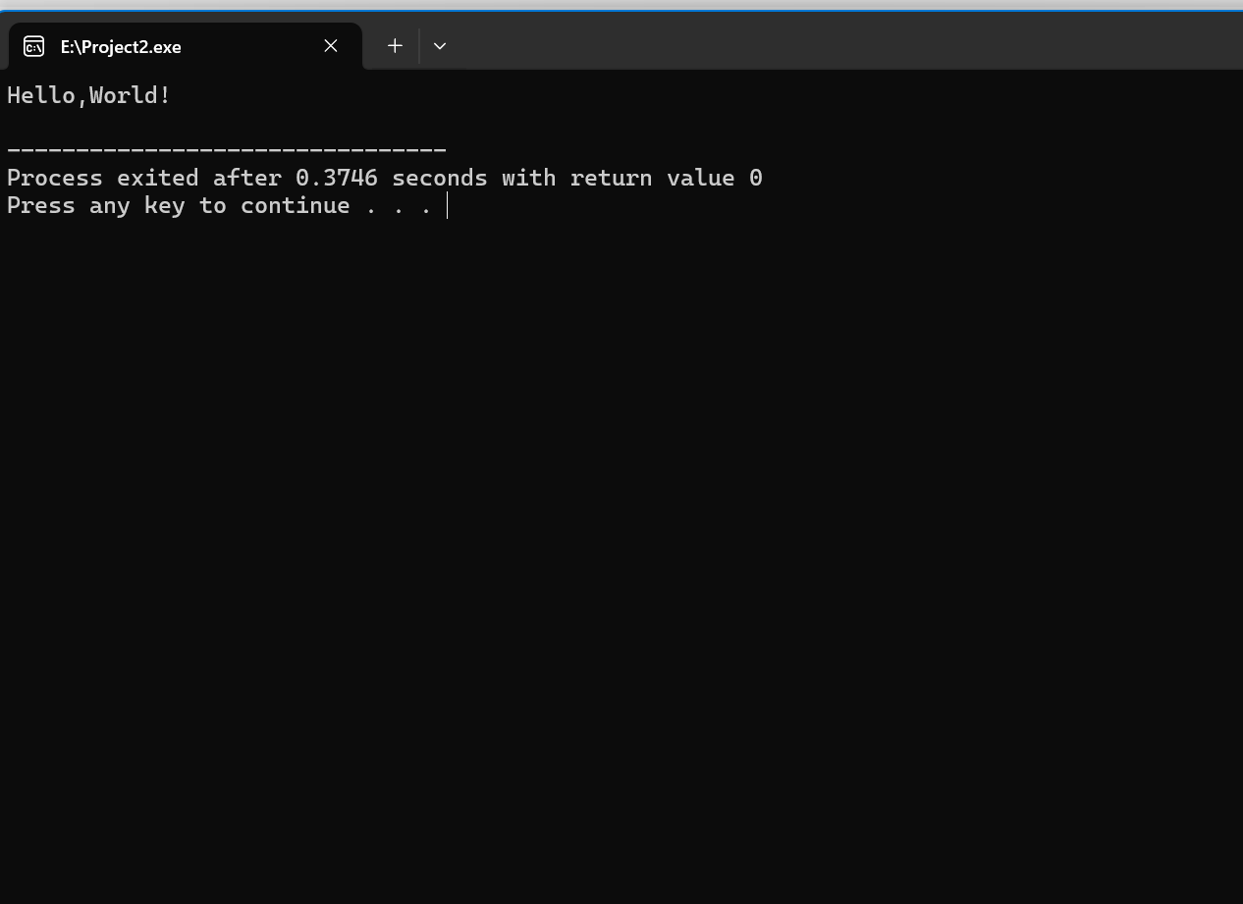

After installation github I start to use it by create a repository, clone and add a path.

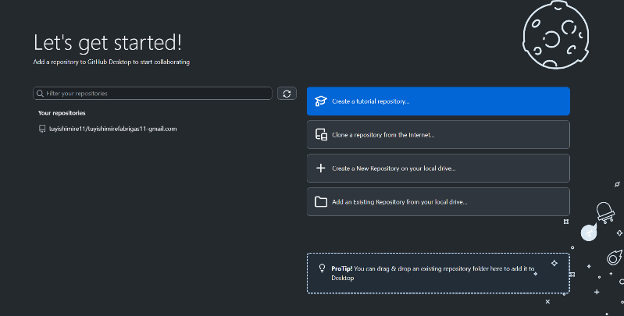

Those are the default dev diplays below

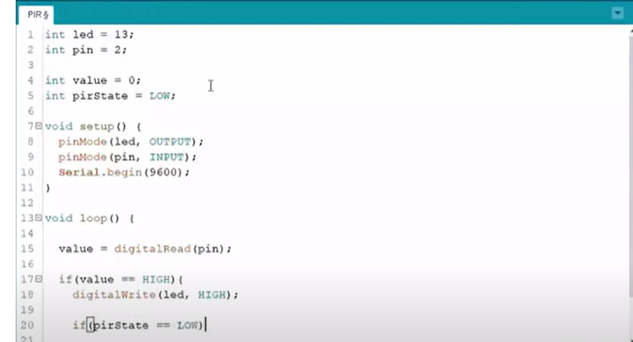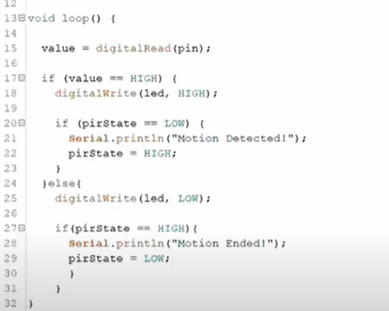

After uploading the project from dev c to the github in order to allow collaborators to work on a project.

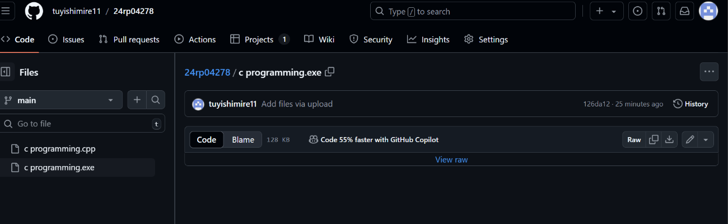

By conclusion,I start by making a research about a github and I create an account, then I add/invite a collaborator.

Apart of that I try to install github and dev c++ for helping me create a project by write “hello ,world ” in dev c++ and it run hello world.

After get a real display I save the project and go to the github account for uploading my project as shown obove.